Practice Questions

1 Write the equilibrium constant expression for each of the following.

Equation | 2 SO₂(g) + O₂(g) 2 SO₃(g)
Equilibrium constant expression
(1 mark)

Equation | PbCl₂ (s) Pb²⁺ (aq) + 2 Cl⁻ (aq)
Equilibrium constant expression
(1 mark)

2. The uptake of carbon dioxide from the atmosphere by the oceans is leading to gradual acidification of the oceans (i.e. the oceans are becoming less alkaline). When carbon dioxide dissolves, it reacts with water to form carbonic acid, which in turn forms hydrogencarbonate and then carbonate ions.

(a) Write equilibrium equations that show the formation of these products in water.

One of the most significant consequences of ocean acidification is the effect on shellfish and other marine life that produce and rely on calcium carbonate as a major component of the exoskeleton or other supporting structure. If the water is sufficiently acidic, the carbonate structures may not form completely. Ocean acidification is thought to lead to a reduction in the availability of carbonate ions. Further reaction of the dissolved carbon dioxide occurs as shown below.

CO₂ (g) + CO₃^{2–} (aq) + H₂O () 2 HCO₃– (aq)

(b) What can you conclude about the magnitude of the equilibrium constant for the above reaction, and the relative proportions of products and reactants in the system? (2 marks)

3.
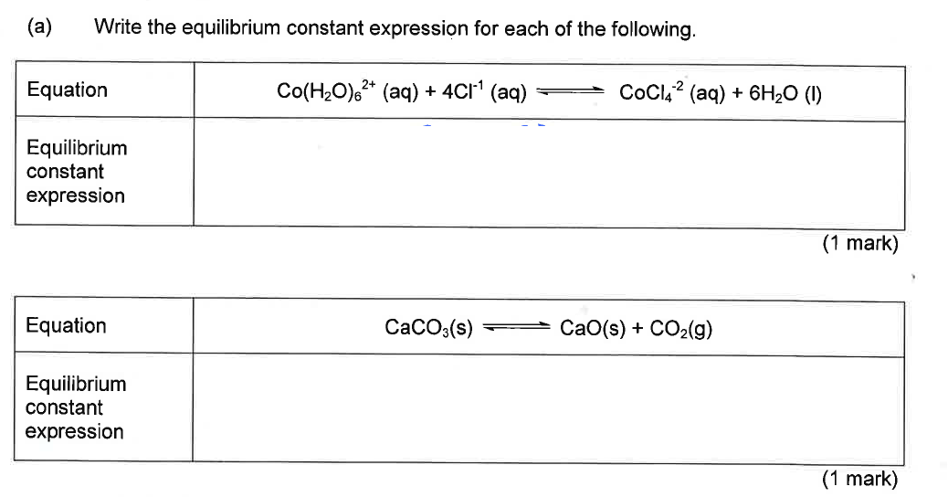
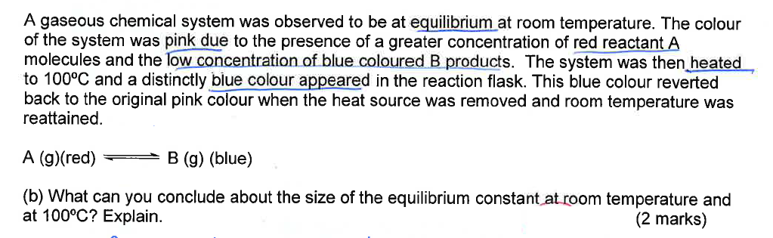
_____________________________________________________________________________________________________________________________________________________________________________________________________________________________________________________________________________________________________________________________________________________________________________

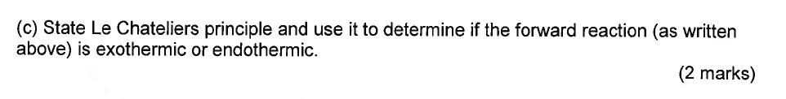

_____________________________________________________________________________________________________________________________________________________________________________________________________________________________________________________________________________________________________________________________________________________________________________

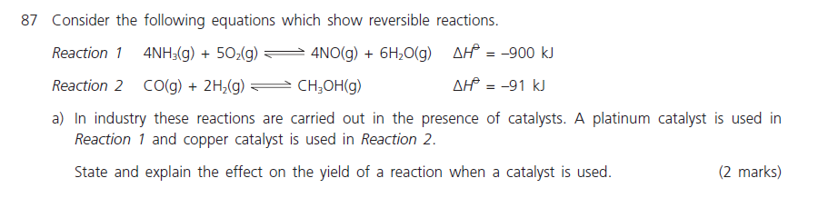
4.

5. 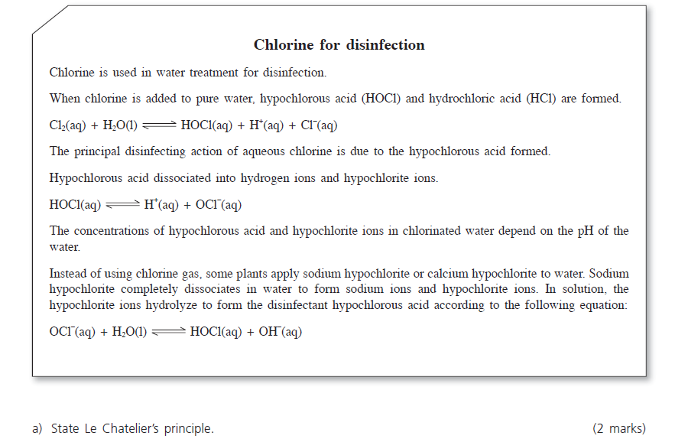

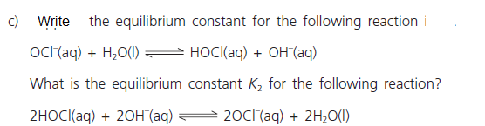

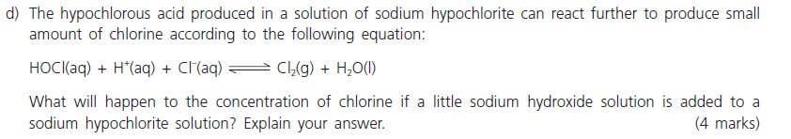

Anskey

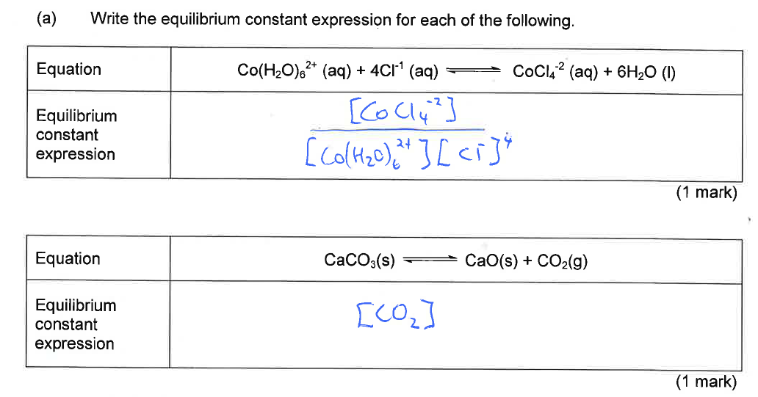
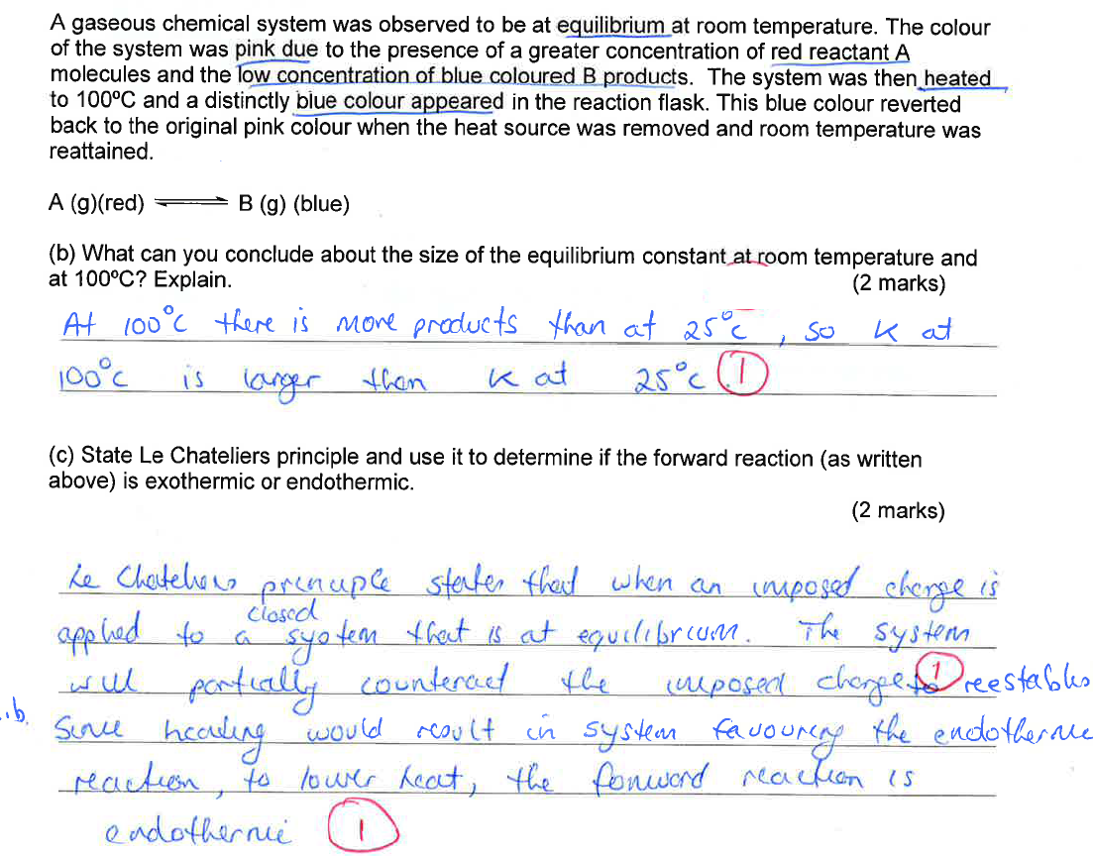

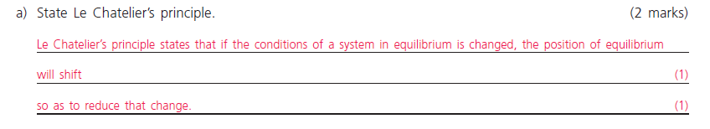
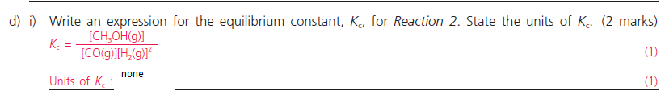
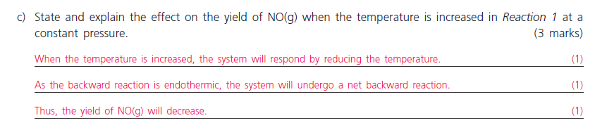
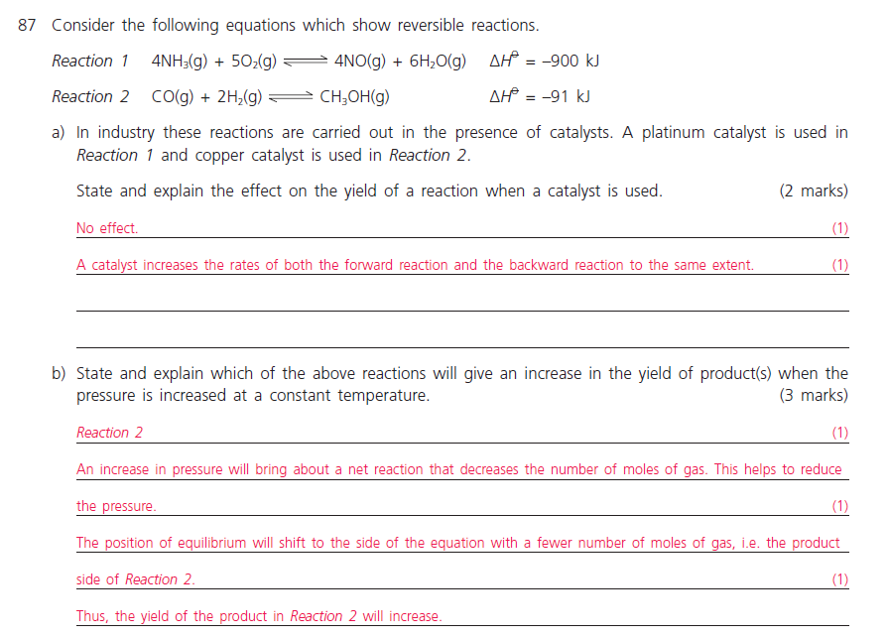
5.

